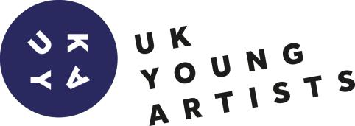

EQUAL OPPORTUNITY FORM

EQUAL OPPORTUNITIES MONITORING FORM -STRICTLY CONFIDENTIAL
UK Young Artists,Primary and BCJEM are committed to a policy of equality of opportunity and anti-discriminatory practices in respect of the protected characteristics as defined in the Equalities Act 2010.In order to assist us with the monitoring of equality of opportunity, please complete this section. Please note this information is requested for equal opportunities monitoring purposes only and will not be used to make a decision on your application
1. | Gender: | ☐Male | ☐ Female | ☐Prefer not to disclose
2. | Age: | ☐Under 18 -22 | ☐ 22-26 | ☐26 -30

3. Which of the following describes your sexual orientation?

☐Bi-sexual ☐Gay woman/lesbian ☐Gay man

☐ Heterosexual ☐Other ☐Prefer not to disclose

How would you describe your ethic origin?

UK Young Artists works closely with our partner universities to develop skills and employability of students and graduates. To evaluate the impact of this work, it is useful for us to capture data about which universities artists have attended. Please select the option that applies to you:

I have attended:
Loughborough University
Nottingham Trent University
De Montfort University
University of Derby
Other, please state_____________________________________
Self-taught
None
“A physical or mental impairment which has a substantial and long-term adverse effect on a person’s ability to carry out normal day-to-day activities. The disability could be physical, sensory or mental and must be expected to last at least 12 months.”

Are you a disabled person as defined by the Disability Discrimination Act?
☐Yes ☐No
If yes, please specify: ………………………………………………………………………………………………………

